**Machine precision number eps**

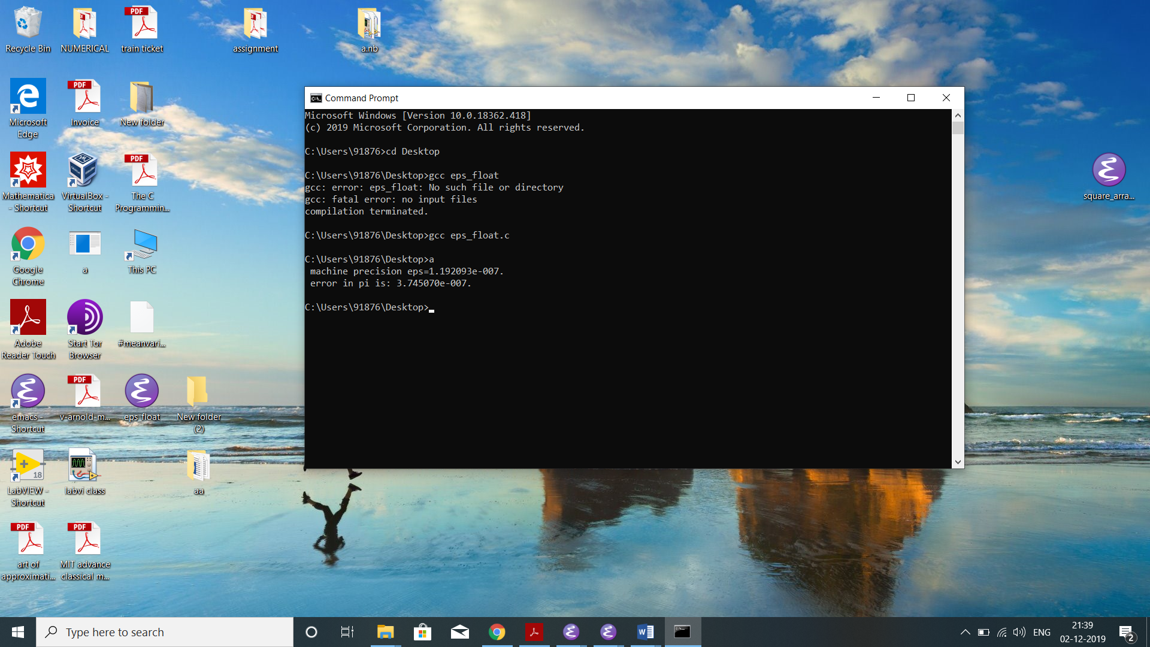

1. There is no relative round off error in 2.0 because it is of int type.
2. Yes both and 2 are machine number since and . .